**Grid Configuration Using JSON:**

//Hub_config.json:

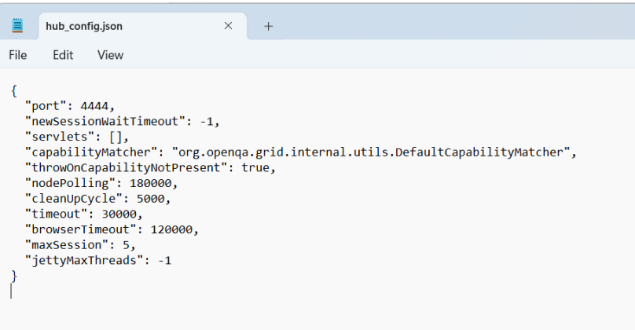

**Java -jar selenium-server-standalone-3.141.59.jar -role hub -hubConfig**

**Hub_config.json:**

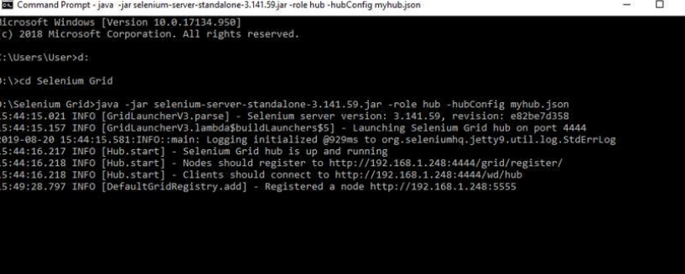

**Mynodes.json:**

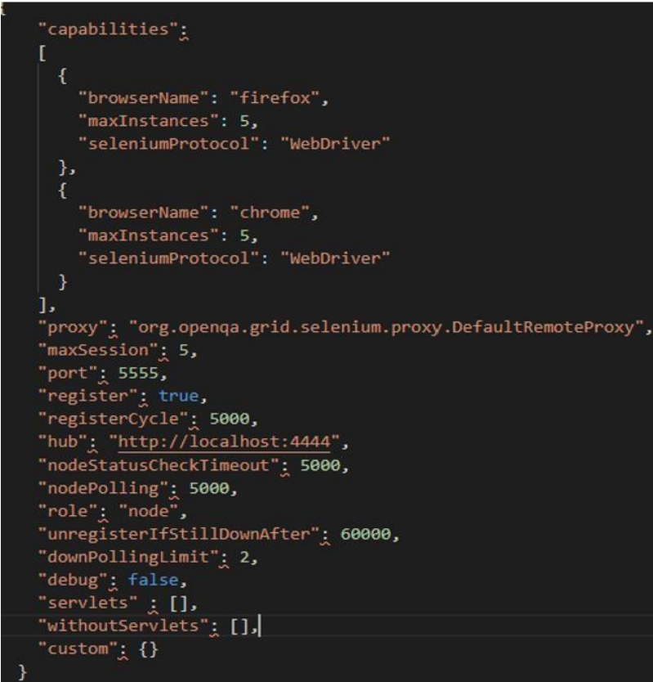

**java -Dwebdriver.gecko.driver="geckodriver.exe" -**

**Dwebdriver.chrome.driver="chromedriver.exe" -jar selenium-serverstandalone-3.141.59.jar -role node -nodeConfig mynodes.json**

